Supplementary Table 1: The pre- and post-transplant clinical parameters between rejection and non-rejection group. The values are represented as mean ± SD or as median (Q1, Q3)
Clinical Parameters | Rejection | Non-rejection | p-value
Pre-transplant Urea (mg/dL) | 82.3 (66.75, 112.25) | 87.3 (72.0, 110.50) | 0.67
One-month post-transplant urea (mg/dL) | 43 (37.5, 52.0) | 44 (38, 55) | 0.88
Three months post-transplant urea (mg/dL) | 47.5 (34.5, 57.25) | 44.5 (38.25, 51.75) | 0.81
Pre-transplant albumin (gm/dL) | 4.27 (3.96, 4.42) | 4.05 (3.90, 4.26) | 0.18
One-month post-transplant albumin (gm/dL) | 4.2 (3.8, 4.6) | 4.1 (3.8, 4.45) | 0.61
Three months post-transplant albumin (gm/dL) | 4.13 (3.85,4.3) | 4.2 (3.92, 4.51) | 0.38
Pre-transplant bilirubin (mg/dL) | 0.47 (0.40, 0.52) | 0.57 (0.48, 0.70) | 0.01
One-month post-transplant bilirubin (mg/dL) | 0.50 (0.33, 0.69) | 0.56 (0.41, 0.96) | 0.31
Three months post-transplant bilirubin (mg/dL) | 0.40 (0.36, 0.49) | 0.61 (0.44, 0.78) | 0.01
Pre-transplant haemoglobin (gm%) | 8.75±1.62 | 10.18±1.05 | 0.00
One-month post-transplant haemoglobin (gm%) | 10.09±2.73 | 10.60±1.57 | 0.47
Three months post-transplant haemoglobin (gm%) | 11.00±2.50 | 11.45±2.56 | 0.61
Pre-transplant RBC (value*10^6/µl) | 3.13±0.60 | 4.01±1.53 | 0.06
One-month post-transplant RBC (value*10^6/µl) | 3.44±0.99 | 3.83±0.62 | 0.15
Three months post-transplant RBC (value*10^6/µl) | 3.89±0.90 | 4.18±0.90 | 0.35
Pre-transplant WBC (value*10^3/µl) | 8.29±2.51 | 8.09±1.99 | 0.79
One-month post-transplant WBC (value*10^3/µl) | 11.84±4.48 | 12.80±4.85 | 0.56
Three months post-transplant WBC (value*10^3/µl) | 10.69±3.49 | 10.62±3.99 | 0.96
Pre-transplant neutrophils (%) | 64.22 (58.14, 69.78) | 67.32 (60.69, 69.75) | 0.52
One-month post-transplant neutrophil (%) | 69.9 (61.25, 88.85) | 75.5 (64.85, 88.05) | 0.43
Three months post-transplant neutrophil (%) | 72.5 (69.4, 79.37) | 76.75 (66.5, 82.40) | 0.83
Pre-transplant eosinophils (%) | 5.17 (3.97, 6.92) | 3.50 (2.36, 6.51) | 0.27
One-month post-transplant eosinophils (%) | 0.70 (0.50, 1.45) | 0.50 (0.3, 0.85) | 0.67
Three months post-transplant eosinophils (%) | 0.50 (0.31, 1.0) | 0.45 (0.33, 0.75) | 0.69
Pre-transplant basophils (%) | 0.37 (0.28, 0.47) | 0.38 (0.28, 0.51) | 0.79
One-month post-transplant basophils (%) | 0.10 (0.00, 0.15) | 0.10 (0.1, 0.2) | 0.07
Three months post-transplant basophils (%) | 0.15 (0.08, 0.23) | 0.15 (0.1, 0.28) | 0.63
Pre-transplant lymphocytes (%) | 22.85 (17.78, 28.30) | 22.08 (18.62, 26.35) | 0.69
One-month post-transplant lymphocytes (%) | 21.60 (5.60, 25.30) | 16.3 (7.60, 26.80) | 0.86
Three months post-transplant lymphocytes (%) | 19.2 (14.02, 23.32) | 17.80 (11.8, 24.05) | 0.93
Pre-transplant monocytes (%) | 7.47 (6.95, 8.15) | 6.98 (5.56, 7.88) | 0.21
One-month post-transplant monocytes (%) | 8.0 (4.65, 11.35) | 6.4 (3.65, 8.75) | 0.18
Three months post-transplant monocytes (%) | 6.25 (4.83, 7.8) | 5.6 (4.23, 8.27) | 0.61
Pre-transplant platelets (%) | 235.67 (176.59, 285) | 203.33 (163.5, 221.3) | 0.06
One-month post-transplant platelets (%) | 279 (195, 346) | 278 (209.5, 324) | 1.00
Three months post-transplant platelets (%) | 307 (238.5, 382.75) | 246 (195, 317) | 0.16

Supplementary table 2: Post-hoc analysis showing the median difference between the timelines for cytokines
Timeline changes of cytokines | Mean difference | p-value
Cytokine FOXP3
Pre-transplant with one - month post-transplant | 5.46 | <0.01
Pre-transplant with three - months post-transplant | 10.92 | <0.01
One - month post-transplant with three - months post-transplant | 5.46 | <0.01
Cytokine IL-6
Pre-transplant with one - month post-transplant | 4.61 | <0.01
Pre-transplant with three - months post-transplant | 12.56 | <0.01
One - month post-transplant with three - months post-transplant | 7.95 | <0.01
Cytokine IL-17
Pre-transplant with one - month post-transplant | -4.6 | 0.51
Pre-transplant with three - months post-transplant | -5.63 | 0.50
One - month post-transplant with three - months post-transplant | -1.03 | 0.94
Cytokine TGF-beta
Pre-transplant with one - month post-transplant | 237.91 | <0.01
Pre-transplant with three - months post-transplant | 298.35 | <0.01
One - month post-transplant with three - months post-transplant | 60.44 | <0.01

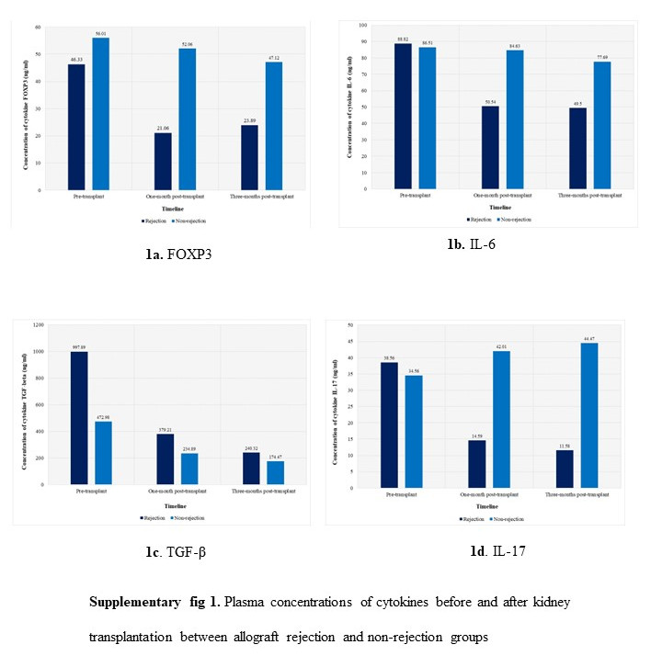
Supplementary figure 1: Plasma concentration of the cytokines before and after kidney transplant between allograft rejection and non-allograft rejection groups.

